How to Run the Conversational SQL Query Validator Model

Github-Link: https://github.com/abdallakhalil/Conversational-SQL-Query-Validators

### **Step 1: Clone the Repository**

Begin by cloning the codebase from the repository. Open your terminal and enter the following command:

git clone https://github.com/abdallakhalil/Conversational-SQL-Query-Validators.git

### **Step 2: Verify Python and Pip Installation**

Make sure Python 3.x and pip are installed on your system. You can check this by executing:

python --version

pip --version

If these are not installed, download Python from the official website at [Python Downloads](https://www.python.org/downloads/).

### **Step 3: Install Required Libraries**

Navigate to the project directory and install the necessary libraries with pip:

cd Conversational-SQL-Query-Validators

pip install -r requirements.txt

### **Step 4: Install OLLAMA**

To use the offline model, you need to install OLLAMA. Download the installer from [OLLAMA Setup](https://ollama.com/download/OllamaSetup.exe) and follow the installation instructions.

### **Step 5: Download and Set Up the Ollama Model**

Download the "ollama_finetuned" model from the provided Google Drive link:

https://drive.google.com/file/d/1Fvtszab5VSVssRVE9IjppeCivQH9-Wz0/view?usp=sharing

Extract the downloaded file and add the path to the "ollama_finetuned" folder to both your environment variables and system variables.

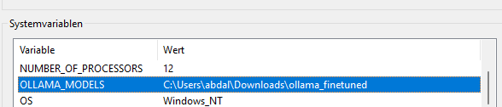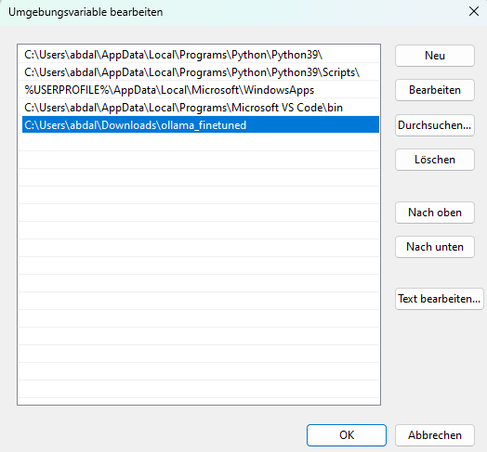

### **Step 6: Verify Environment Variable**

To confirm that the path is set correctly, use the following command in the terminal:

echo %OLLAMA_MODELS%

The correct path should be displayed as a response.

### **Step 7: Pull the OLLAMA Model**

Open the terminal in Visual Studio, and pull the model with the following command:

ollama pull mistral

### **Step 8: Run the Gradio Interface**

With the setup complete, navigate to the project directory in the terminal and run:

python new_gradio_mistral.py

### **Step 9: Access the Gradio App**

Once the command runs, a link to the Gradio app will appear in the terminal. It is typically:

http://127.0.0.1:7860/

Open this link in your web browser to interact with the offline model using the provided user interface.

### **How to run the online model**

For the online model, you'll need an API key for GPT-3.5 or similar. Set the API key as an environment variable typically named OPENAI_API_KEY.

Check the path or API key by echoing the respective variable in the terminal:

echo %OPENAI_API_KEY%

python new_gradio_gpt.py